**Flounder Crochet Pattern**

***\*2mm Hook – 8mm Eyes\****

**Body;**

*Yellow*

R1: SC5 into MR [5]  
R2: SC2, Inc, SC2 [6]  
R3: Inc, SC1, Inc x2, SC, Inc [10]  
R4: SC, Inc x7, SC2 [17]  
R5: SC4, (Inc, SC) x5, SC3 [22]  
R6: SC5, (Inc, SC) x6, SC5 [28]  
R7: SC6, (Inc, SC) x8, SC6 [36]  
R8: SC around [36]  
R9: SC around [36]  
R10: SC8, *Dark Blue* SC20, *Yellow* SC8 [36]   
R11: SC8, *Dark Blue* SC20, *Yellow* SC8 [36]  
R12: SC around [36]  
R13: SC around [36]  
*Place eyes 8 stitches apart, 3 rounds from the dark blue*  
R14: SC10, *Dark Blue* SC16, *Yellow* SC10 [36]  
R15: SC10, *Dark Blue* SC16, *Yellow* SC10 [36]

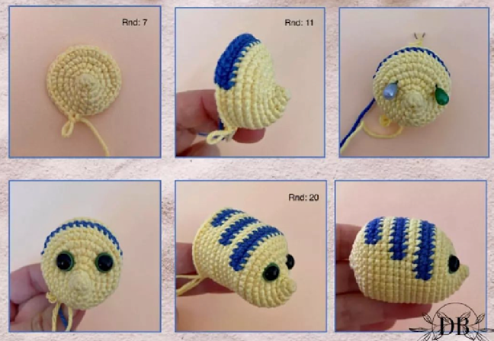R16: SC around [36]  
R17: SC around [36]  
R18: SC12, *Dark Blue* SC12, *Yellow* SC12 [36]  
R19: SC12, *Dark Blue* SC12, *Yellow* SC12 [36]  
R20: SC around [36] *Stuff body*  
R21: (SC4, Dec) x6 [30]  
R22: (SC3, Dec) x6 [24]

R23: (SC2, Dec) x6 [18]  
R24: (SC1, Dec) x6 [12]  
R25: Dec x6 [6]  
*Sew closed the body*

**Tail;**

*Dark Blue*

R1: Ch10, turn [10]  
R2: *2nd Ch from hook*, SC8, SC3 into last Ch, SC7, Inc [20]

*Light Blue*  
R3: SC20 [20]

R4: (Dec, SC8) x2 [18]  
R5: (Dec, SC7) x2 [16]

R6: SC16 [16]  
R7: (Dec, SC6) x2 [14]  
Cut yarn, leave long tail for sewing.

**Dorsal Fin x2;**\*Dark Blue*  
R1: Ch6 and turn [6]  
R2: SC4, SC3 into last Ch, SC3, Inc [12]  
*Light Blue*

R3: SC12 [12]  
R4: (Dec, SC4) x2 [10]  
R5: SC10 [10]

Cut yarn, leave long tail for sewing.

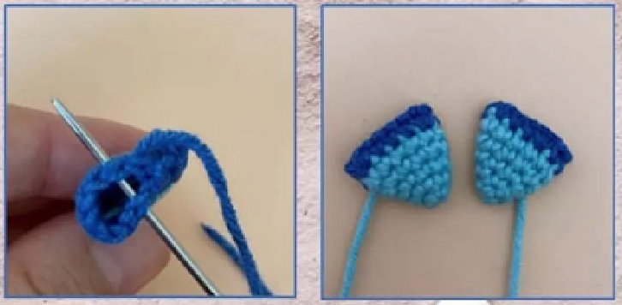**Pectoral Fin x2;**\*Light Blue*  
R1: SC4 inti MR [4]  
R2: (SC, Inc) x2 [6]  
R3: (SC, Inc) x3 [9]  
R4: (SC2, Inc) x3 [12]

R5: SC12 [12]  
*Dark Blue*   
R6: (SC3, Inc) x3 [15]  
Cut yarn, sew opening flat in half and cut tail for sewing.

**Hair;**

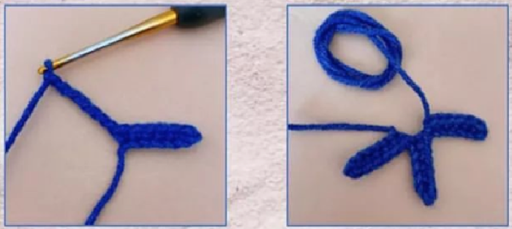*Dark Blue*  
Ch7, turn, SC1 in each of the 6 chains, Ch7, SC1 in each of the 6 chains, Ch7, SC1 in each of the 6 chains.  
Cut yarn, leave tail for sewing.

